1. **Write the c program to implement binary tree traversal.**

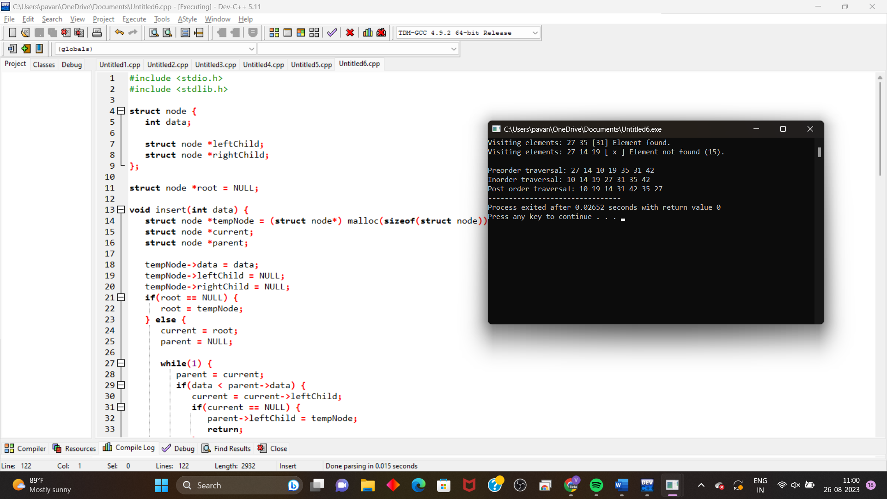

1. **Write the c program to implement AVL tree with all rotations .**

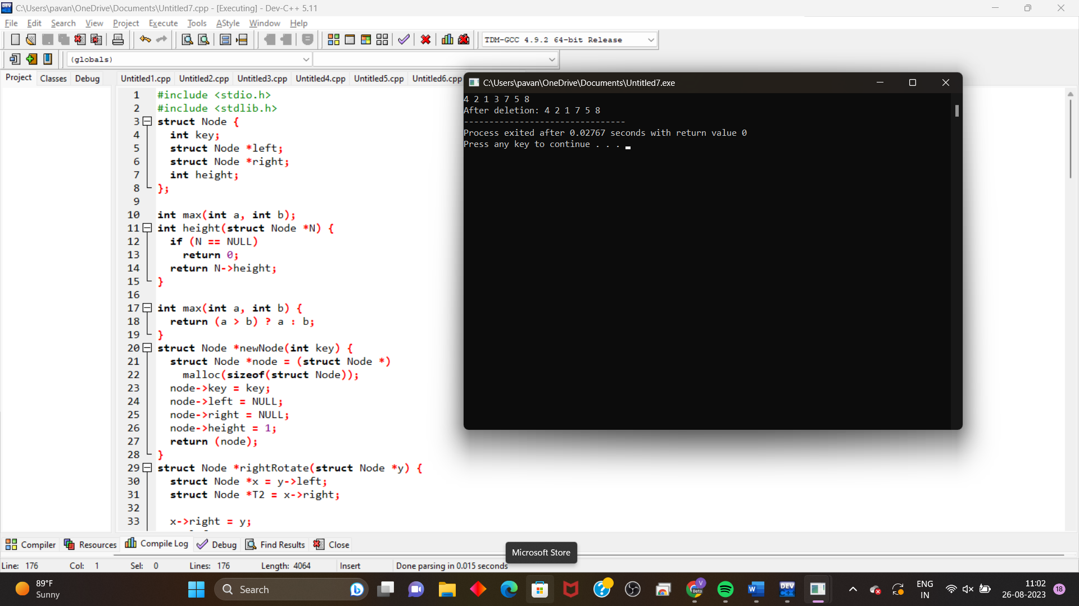

**3.write the c program to implement using linear probing technique .**

